**Install Python on Windows**

1. Download Python 2 for Windows from the official website: <https://www.python.org/>

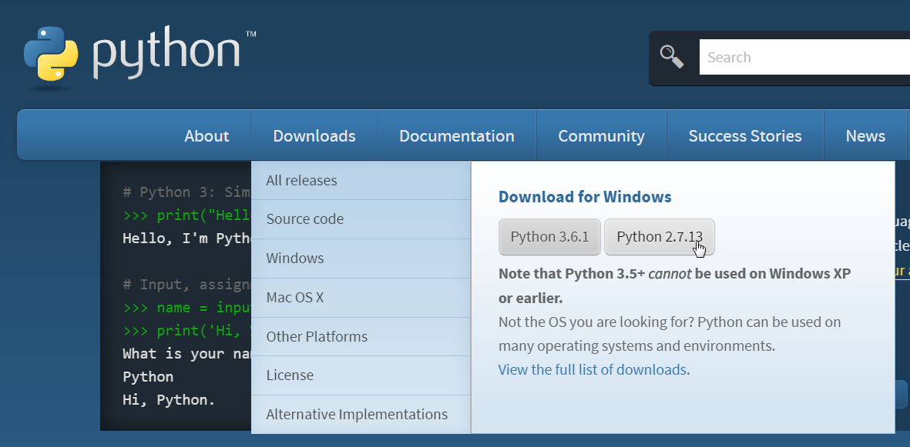

1. Install Python (keep default settings)

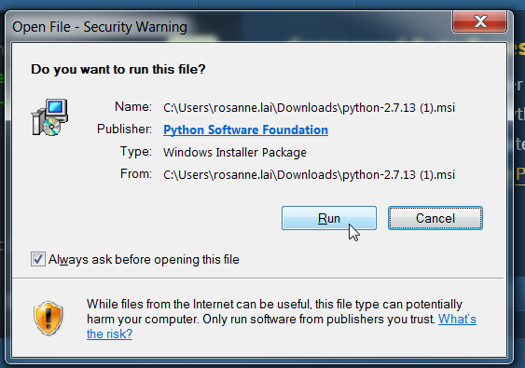

1. After you have installed Python, search“Edit the system environment variables” in your start menu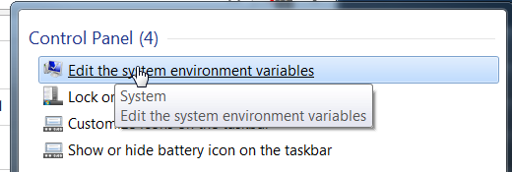
2. Select the “Advanced” tab and click on “Environment Variables”

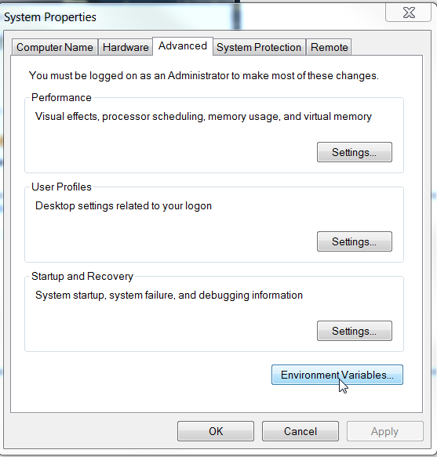

1. Select “New” under “System variables”

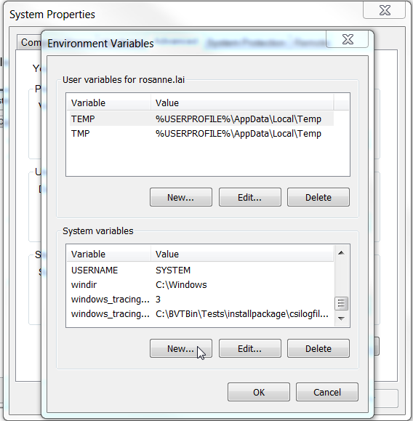

Create a new system variable with Variable name: “PYTHON_HOME” with a Variable Value: “C:\Python27\”

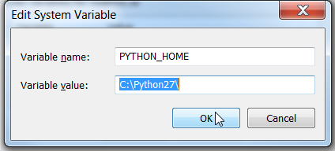

1. Then, select the **pre-existing system variable** named “Path” and click “Edit”

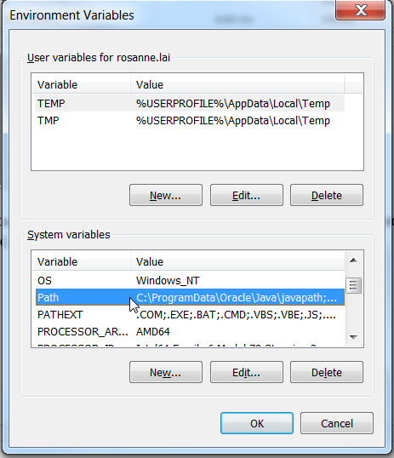

Add “\;%PYTHON_HOME%\;%PYTHON_HOME%\Scripts” **to the end of the pre-existing Variable Value**

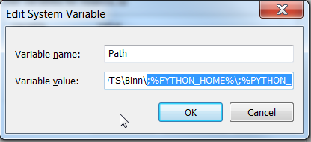

This will allow Python to be called from any location.

1. Download the pip installation file from: <https://bootstrap.pypa.io/get-pip.py>

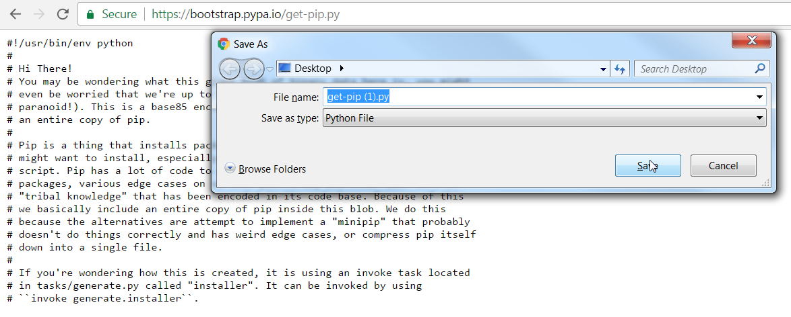

Save as a Python file on your computer. Click on the downloaded file to run.

We will be using pip later to install packages that we need to run our scripts.

1. After you have installed Python, run the command prompt from your start menu

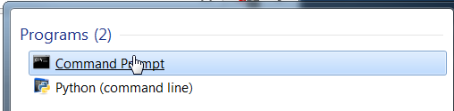

1. Type “python” and hit enter to check that Python 2 has installed correctly

